Student Management

Create Course

Version <1.0>

Revision History

|  |  |  |  |
| --- | --- | --- | --- |
| **Date** | **Version** | **Description** | **Author** |
| <dd/mmm/yy> | <x.x> | Final version | Đào Anh Thành |
|  |  |  |  |
|  |  |  |  |
|  |  |  |  |

Table of Contents

1. Create course 3

1.1 Brief Description 3

2. Flow of Events 3

2.1 Basic Flow 3

2.2 Alternative Flows 3

2.2.1 < First Alternative Flow > 3

2.2.2 < Second Alternative Flow > 3

3. Special Requirements 3

3.1 < First Special Requirement > 3

4. Preconditions 3

4.1 < Precondition One > 3

5. Postconditions 3

5.1 < Postcondition One > 3

6. Extension Points 3

6.1 <Name of Extension Point> 3

Creating new course

# Create new course

## Brief Description

This use case defines the steps of adding a new course to store it in the database system. Administrator can easily add a new course in the database.

## Actor

Administrator

# Flow of Events

## Basic Flow

The system administrator selects to add a new course and enters all information of this course to store in the database system. The administrator sets the database management parameter that holds course information that has just added. The system displays the new course’s data value and logs the change.

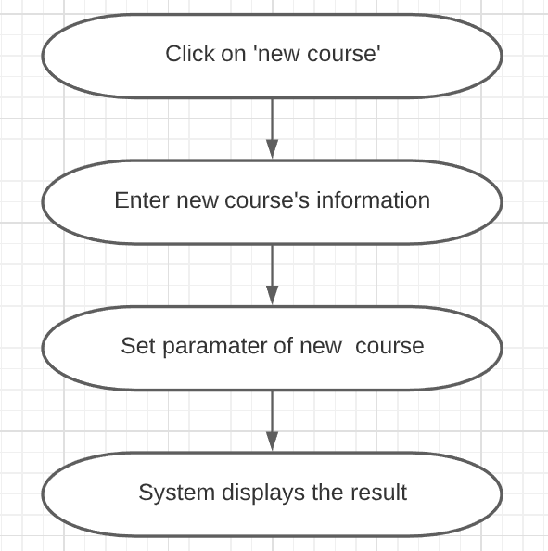

# Special Requirements

Administrator has basic knowledge of manipulating the database.

# Preconditions

The added course had not existed in the database before.

# Postconditions

Administrator checks the database and the website to ensure that the new course is added successfully.

# Extension Points

No extension points.